Using LDP.EXE

Introduction
LDP.EXE is a graphical utility that allows users to perform LDAP operations (such as connect, bind, search modify, add, delete) against any LDAP compatible directory such as the Active Directory. It is highly recommended that you read the Understanding LDAP whitepaper before continuing with this document.

http://www.microsoft.com/WINDOWS2000/library/howitworks/activedirectory/ldap.asp

Starting LDP
LDP.EXE is a GUI based, explorer like utility with the scope pane on the left used for navigating through the Active Directory namespace and a results pane on the right hand side, used for displaying the results of the LDAP operations. Any text displayed in the results pane can be selected with the mouse and “copied” to the clipboard.
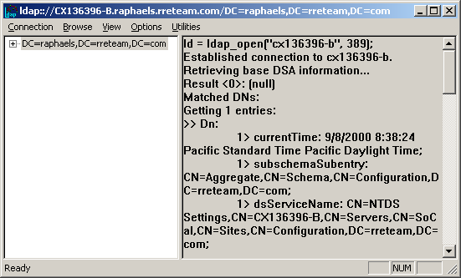

LDP Menu selections
LDP makes extensive use of menu commands to perform the various LDAP operations.

Connection Menu

Connect
Connecting is the most basic function in LDP. To perform any other function in LDP 2 basic things need to happen. First you need to Connect to a specific LDAP server, secondly you need to Bind to that server. To Connect to a Server

- Open LDP
- Select Connection
- Select Connect

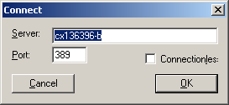

At this point you are prompted for a Server Name, Port Number and whether or not you want to connect via a connectionless or connection oriented connected. If you choose the defaults (empty server field, port 389, connection oriented), you will connect to the current DC that you are authenticated against (This function performs a DSGETDCNAME API Call). If you are not a member of a domain or you wish to connect to another/specific DC, you must enter in the server name.

Port numbers are specific as to what LDAP port you would like to connect to. The 2 most common LDAP ports are 389 and 3268. Port 389 is the standard LDAP port. Port 3268 is the common GC (Global Catalog) LDAP Port. Port 636 is for SSL.

Connection vs Connectionless is determined on the IP connection you wish to make. UDP traffic is connectionless. UDP assumes that the client does not need to verify that the packet was received and processed by the server. Where as Connection oriented or TCP traffic requires server verification. The preferred and most common method is connection-oriented session.

Upon successful connection to a domain controller, the RootDSE information will be displayed in the results pane. The RootDSE information is available to the public, and it does not require any authentication.

For more information on RootDSE please see
Windows 2000: LDAPv3 RootDSE [ntrelease]
ID: Q219005

Bind
The Bind dialog allows the user to submit their credentials for authentication during the LDAP session. Again, leaving these fields blank, LDP will use the currently logged on user’s credentials. To perform a Bind

- Open LDP
- Select Connection
- Select Bind

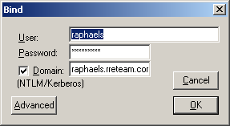

If you leave the creds blank or <NULL>, LDP will assume your current credentials. Other wise you can enter a UserName, Password, and Domain. If you leave the domain blank or <NULL> LDP will assume the current DomainName. Also, the Domain Check box assumes that the LDAP server you are connecting to understands either NTLM or Kerberos Authentication. To select an alternate authentication method

- Select Advanced
- Select Method

You can choose to perform the function synchronously or not. A synchronous function call must return before the client application can continue executing. An asynchronous function allows the client to continue performing other tasks, including making new requests to the server or processing the results of a search.

Entering an invalid username will result in a successful bind, however the bind will be anonymous.

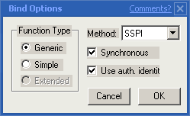

You can also choose between Types. Generic or Simple. Simple use’s standard clear text authentication while generic use’s standard encryption methods.

These are the different type of Bind methods we support:

- Simple: Clear text password. try not to use this as it's not secure.

- MSN: MSN (Microsoft Network) authentication. This package may bring up UI to prompt the user for MSN credentials.

- DPA: Normandy authentication... new MSN authentication. Same usage as MSN.

- NTLM: NT domain authentication. Use NULL credentials and we'll try to use default logged in user credentials.

- Sicily: Negotiate with the server for any of: MSN, DPA, NTLM Should be used for LDAPv2 servers only.

- Negotiate: Use GSSAPI Negotiate package to negotiate security package of either Kerberos v5 or NTLM (or any other package the client and server negotiate). Pass in NULL credentials to specify default logged in user. If Negotiate package is not installed on server or client, this will fall back to Sicily negotiation.

For all bind methods except for Simple, you may pass in a
Authentication Identity (default) to specify alternate
credentials.

All bind methods other than simple are synchronous only calls.
Calling the asynchronous bind call for any of these messages will
return an error.

Using any other method besides simple will cause WLDAP32 to pull in
the SSPI security DLLs (SECURITY.DLL etc).

On non-Simple methods, if you specify NULL credentials, we'll attempt to use
the default logged in user.

Note that the information viewable through LDP is based on the provided credential. In the default environment, Enterprise Administrators have access to all information, but users with other credentials would be restricted to objects that they have proper permissions to view.

If you bind before you connect, LDP will connect the last saved (or default) target server as set in the connect dialog. This can be useful if you repeatedly connect to the same server.

Disconnect
If you choose to connect to another server, you first need to disconnect from the current server. To perform this function either close and reopen a new LDP window or

- Select Connection
- Select Disconnect
- Select Connect

Closing LDP will automatically disconnect your current LDAP session.

New
Selecting New will leave your current Connection and Bind the same, but this will clear the results pane. The information shown on the results pane is accumulative. Thus it is easier to browse information for a given object when the results pane is cleared through “New” command. To clear the right pane

- Select Connection
- Select New

Use the keyboard shortcut [CTRL]-N to clear the right pane.

Save/Save As
This will save the contents of the results pane to a text file.

Browse Menu

Add
The add dialog allows the user to add objects to the Active Directory. The full distinguished name of the object must be entered as well as all the mandatory attributes for the class of object being added.

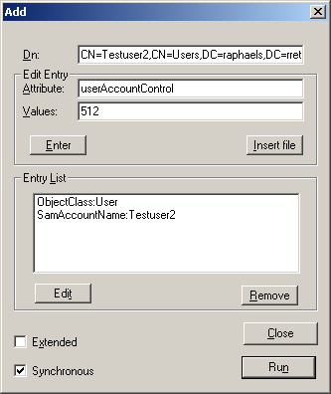

In this example, a new user name “Testuser2” is added to the “Users” container. The DN for the new user object is “CN=Testuser2,CN=Users,DC=raphaels,DC=rreteam,DC=com”. “Edit Entry” part of the menu allows an attribute and associated value to be entered. All the attributes and associated values to be entered will be displayed on the “Entry List” box. Once the desired list of attributes are entered, selecting “Run” would invoke LDAP APIs to enter the object with the listed attributes. If there is any error, the object would not be added, and the error message will be displayed on the results pane.

Note: multi-valued attributes may be entered separated by a semi-column (e.g. mail-addresses: usr1@hotmail.com;usr1@microsoft.com).
What about Insert File, Extended, and Synchronous? You could point to other sections.

Delete
The delete dialog permits the user to delete any object in the Active Directory. The full distinguished name of the object must be entered. If the selected object is a container, then the checkbox option “Recursive” will cause LDP to recur the container and delete all child objects.

Note: Recursive will perform the recursion on the client (LDP). More efficient tree delete can be achieved by using the extended form & specifying the control "1.2.840.113556.1.4.805" (see control usage below).

Note: Only extended (& paged search) calls use the controls. All others are V2 implementation and have no awareness of controls.

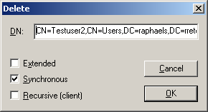

Modify
The modify dialog allows the user to modify the attributes of any object stored in the directory. Again the objects full distinguished name must be entered. Operation selection permits new values to be added or existing values to be deleted or replaced.

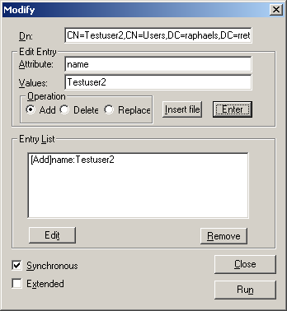

Note: see previous comment about multi-valued attributes data entry.

This dialog has specific operations that it can perform.

- Add: Add’s a value to an existing attribute.
  - Example: “DisplayName” attribute might not exist for Userx. So I would use Modify, then for the operation, select Add.
- Replace: Replaces allows you to replace an existing attributes value with another value.
  - Example: You can replace the “DisplayName” attribute from Joe to <Null>. The attribute still exists in the directory for that user, but it has no specific value.
- Delete: Delete allows you to permantently remove an attribute from an object, only if it is an optional value. Note: attribute definitions per class can be determined manadatory or optional via the schema.
  - Example: To permanently remove “DisplayName” attribute from the object, we would use the Delete. Note: The attribute must contain no data for it to be removed from an object.

Modify RDN
The ModfyRDN dialog allows the user to modify (or rename) an object’s relative distinguished name.

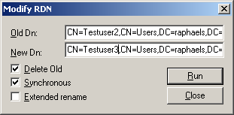

This also permits an object to be moved from one container to another.

Note: Running this against the Active Directory ONLY supports Delete Old. This operation, which is only available to '88 edition systems, is used to change the relative distinguished name of a leaf entry. The operation arguments are the distinguished name of the entry, the new RDN, and an indication of whether or not the old RDN attribute values should be deleted from the entry

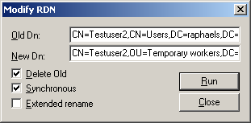

Search
The search operation is used to select entries from a specific region of the directory information tree (DIT) based on customized criteria called a search filter. The following arguments are used to accomplish the search:
- A search base (the distinguished name of the search base object) defines the location in the directory from which to begin searching.
- A search scope defines how deep to search within the search base.
- Base, or zero level, searches the base object only.
- One level searches objects immediately subordinate to the base object but not including the base object itself.
- Subtree searches the entire subtree of which the base distinguished name is the topmost object, including that base object.
- A filter that allows certain entries in the subtree and excludes others.
- A selection that indicates what attributes to return from objects that match the filter.
- Optional controls that affect how the search is processed.

LDAP search filters as defined in RFC 2254 allow you to define search criteria and give you better control to achieve more effective and efficient searches. The search dialog permits searches to be performed against the Active Directory. The search base must be specified as a distinguished name, and the filter must be a valid LDAP filter.

The list of LDAP filter operators:

Ldap Filter Operator | Description
= | Equal
~= | Approximately Equal
<= | Less than or equal to
>= | Greater than or equal to
& | AND
| | OR
! | NOT

LDAP query syntax is in prefix notation. AX AND Y would be expressed as (&(X)(Y)); X OR Y would be expressed as (|(X)(Y)).
For more efficient queries used indexed attributes as the first attribute in the search filter.

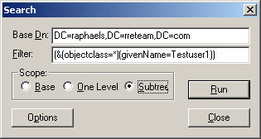

The following section is an excerpt from Q255602, and it gives various examples of using LDAP filter:

If you want to search for all of the users who have first names of John AND last names of either Smith OR Jones, the filter is similar to the following:

(&(objectClass=user)(givenName=John)(|(sn=Smith)(sn=Jones)))

The “!” sign (the NOT operator) can be applied to a single term, as in the following example:

(&(objectClass=user)(sn=Jones)(!givenName=John)(!givenName=Jane)(!logonCount<=100))

The above filter finds users who have the surname Jones whose given name is neither John nor Mary and who have logged on no less than 101 times.
Queries also support asterisk wildcards. The following search returns all of the users who have surnames that start with the letter J:

(&(objectClass=user)(sn=j*))

The LDP utility searches are not case sensitive, and you can search by using leading and trailing asterisks (*string*) to find substrings in the middle of a value. Such searches take much longer to complete. When possible, use either a leading or trailing wildcard character, but not both.
You can use a wildcard by itself to test for the existence or absence of a given attribute. If you want to find all of the users who do not have an Exchange Server mailbox, you can find them by using the following query because these users lack an msExchHomeServerName value:

(&(objectClass=user)(!msExchHomeServerName=*))

The escape character in a query is the backslash (\). This is a reserved character, along with * ( ) and NUL. To search for reserved characters as part of an attribute value, you must precede the reserved characters with the escape character and one of the following numeric codes for each reserved character:

Character | Escape sequence
* | 2a
( | 28
) | 29
\ | 5c
NUL | 00

For example, if you want to search for all of the users whose display names end in a close parenthesis character, use the following search:

(&(objectClass=user)(displayName=*\29))

If you want to find users whose home directories are G:\Accounting, use the following search:

(&(objectClass=user)(home-directory=G:\5cACCOUNTING*))

In an LDAP query, a backslash always signifies an escape character, never an actual backslash.
If you are interested in only a particular attribute or few attributes, you can filter the rest so that they are not displayed in the results window by clicking Options in the Search dialog box. In Options, list the attributes that you want to be displayed, and separate each with a semicolon. For example:

msExchHomeServerName;DisplayName;Home-Directory;

If you leave the Attributes list blank or if it is an asterisk, all of the attributes to which you have access are displayed for every object returned by a query.
NOTE: The LDP utility does not separate the objects that are returned by a query with a blank line. When you look through search results, look for the leading >> characters to indicate the beginning of the next object in the list.

You can also select the options button. This gives the user much more flexibility as to the type of results you would like to return.

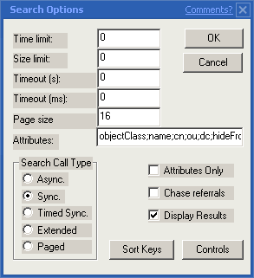

Text Values:
TimeLimit: Time Limit is the amount of time (in milliseconds) that the search should take on the server. For some searches the time can be extensive. This is also dependent of the current load on the server itself.
SizeLimit: Size Limit is the size of the data (in bytes) that the search should return. or Null leaves this value open. Affecting the size limit can help with maximizing throughput of the search.
TimeOut(S/MS):. This is the amount of time that the client should wait on the server to finish.

PageSize: Page Size is the size of the page (in bytes) that the search results should use when sending back the results.
Attributes: This is the list of Attributes that the search should return when the search request is sent. For ALL attrib’s clear the current list and enter “*” (W/out quotes) or just leave it empty. Note that multiple attributes can be entered separated by semi-column. Also, since range and other attribute modifiers use semi-column one can escape those with surrounding quotes.

Example:

“memberof;range:1-20”;ObjectClass;ObjectGUID

CheckBox’s
Attributes Only: Check this box to return only attributes for the selected search. This does not return the DN of the objects.

Chase Referrals: Check this box to search for objects/attributes for an external LDAP Directory. An example would be 2 Forests that are linked by a trust. If an Object in 1 forest had a link to an Attribute in another forest, the DC would return a referral for that attribute. If this check box is not checked, the referral would not be returned an a message stating to look for the referral would be returned.

Display Results: This check box will display the results of the search. If this box is not check only a success or failure would be returned for the search with the count of items found.

Compare
The compare dialog allows the user to compare the value of an object’s attribute with a specified value and returns a result of either true or false.

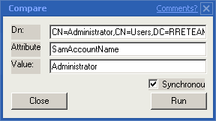

ldap_compare_s(0x7f2024, "CN=Administrator,CN=Users,DC=RRETEAM,DC=NET", "SamAccountName", "Administrator")
Results: TRUE. <6>

Extended Op
The extended operation dialog allows the user to submit an extended LDAP operation to an LDAP Directory by specifying a LDAP Object ID (OID) and an applicable value.

Controls

Controls are used in Ldap v3 extended calls such as ldap_search_ext_s(). They are used to modify or extend an ldap operation. For more information on LDAP Controls see

Windows 2000 Extended LDAP Controls [ntrelease]
ID: Q222560

The following controls (each with unique control object id) are supported by the AD (the information is part of RootDSE) in this example:

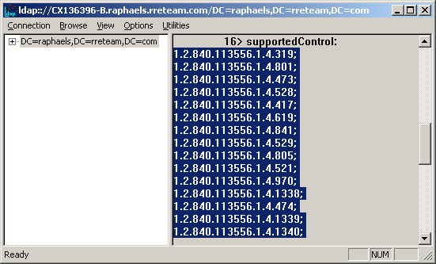

1.2.840.113556.1.4.319; 1.2.840.113556.1.4.801; 1.2.840.113556.1.4.473; 1.2.840.113556.1.4.528; 1.2.840.113556.1.4.417; 1.2.840.113556.1.4.619; 1.2.840.113556.1.4.841; 1.2.840.113556.1.4.529; 1.2.840.113556.1.4.805; 1.2.840.113556.1.4.521; 1.2.840.113556.1.4.970; 1.2.840.113556.1.4.1338; 1.2.840.113556.1.4.474; 1.2.840.113556.1.4.1339; 1.2.840.113556.1.4.1340; 1.2.840.113556.1.4.1413; 1.2.840.113556.1.4.800;

To use extended LDAP operation, you have to add the control’s object id (OID) as shown in the following example:

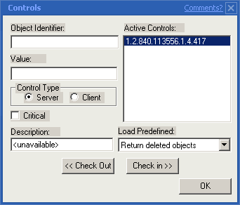

1.2.840.113556.1.4.417 is control OID for “Show Deleted Object.”

The search option should be set to “Extended.”

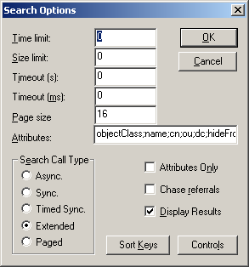

On the search dialog, selecting run would invoke LDAP extended operation.

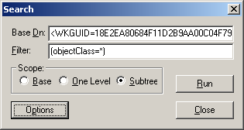

Q258310 has good information on how to use “View Deleted Object” control to view the deleted items.

For an explanation of all Extended controls see

Using Optional Controls Q254213

Security
The security dialog permits the user to view the security descriptor that has been placed on an object. This can be useful when attempting to determine the access permissions to an object.

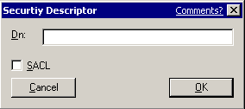

Sample output:

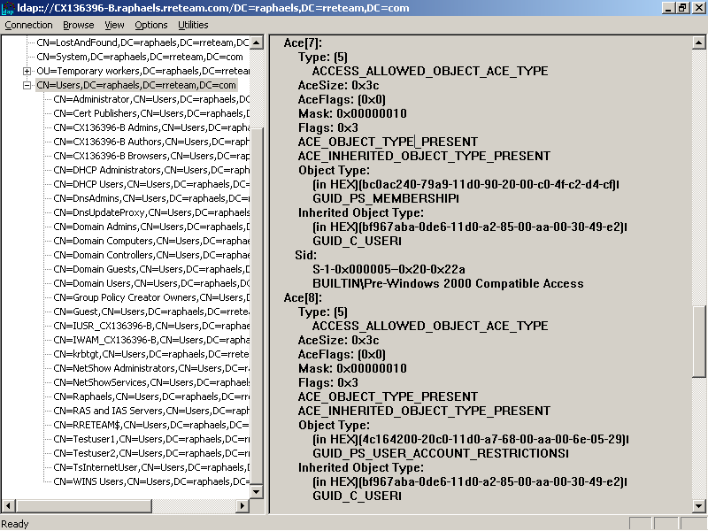

Replication
The replication dialog displays the replication metadata such as Attribute ID, Originating and Local Update Sequence Numbers (USN), GUID of the originating domain controller, date/ time stamps for every attribute of an object. This is useful in identify whether objects have been updated and replicated between the domain controllers. For more Troubleshooting information see

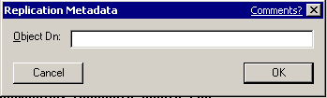

Inter-Site and Intra-Site Replication in Windows 2000
ID: Q271972

Sample output:

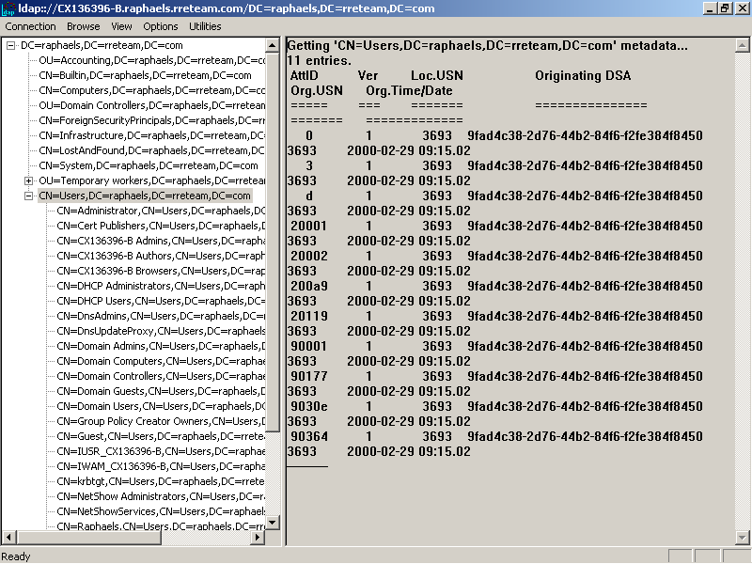

AttID Ver Loc.USN Originating DSA Org.USN Org.Time/Date

===== === ======= =============== ====== ================

0 1 3689 9fad4c38-2d76-44b2-84f6-f2fe384f8450 3689 2000-02-29 09:15.02

20001 1 3689 9fad4c38-2d76-44b2-84f6-f2fe384f8450 3689 2000-02-29 09:15.02

20002 1 3689 9fad4c38-2d76-44b2-84f6-f2fe384f8450 3689 2000-02-29 09:15.02

20119 2 3777 9fad4c38-2d76-44b2-84f6-f2fe384f8450 3777 2000-02-29 09:15.05

90001 1 3689 9fad4c38-2d76-44b2-84f6-f2fe384f8450 3689 2000-02-29 09:15.02

9001a 2 3841 9fad4c38-2d76-44b2-84f6-f2fe384f8450 3841 2000-02-29 09:26.11

90027 1 3777 9fad4c38-2d76-44b2-84f6-f2fe384f8450 3777 2000-02-29 09:15.05

View Menu

Tree
The tree dialog is used to specify the base object to be displayed in the scope pane. If Auto Base DN Query is enabled in the General Options and the Base distinguished name is left blank, the tree view will be rooted at the current default domain for the logged on user.

The tree view permits the user to expand and collapse the child objects, and double clicking on a selected object will display the attributes of that object in the results pane. Right-clicking displays a pop-up menu with popular commands.

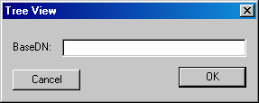

Enterprise Configuration
The enterprise configuration graphically displays all domains and domain controllers in the enterprise. It also indicates whether the domain controllers are online or offline.

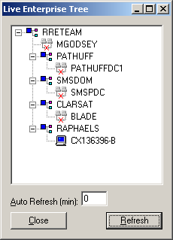

In this example, the domain RAPHAELS is on the network, so the refreshing the display shows the status of connections to other domains with red “X” mark.

Connection Options
Prior connecting to a server, you have the ability to limit and identify specific session options that you want/don’t want LDP to use. An example would be LDAP_OPT_REFERRALS. This control determines whether or not to automatically chase referrals. The default value is 0, yes. To change this value select:

- Options
- Connection Options
- Scroll to LDAP_OPT_REFERRALS
- Change the value to a 1 (Do not chase referrals)

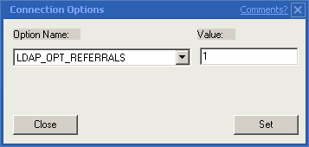

Each connection option has its own set of unique values. These values can be set before a Bind takes place. But other functions can override the current settings. For more information on session options see

http://msdn.microsoft.com/library/psdk/ldap/ld_sesop_67hv.htm

General Options
Connection Options lets you set specific values on what you would like LDP to return when functions are performed.

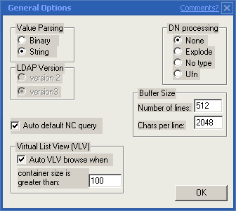

Value Parsing:
Value parsing will determine how you would like LDP to parse out the LDAP values returned. Since everything in the database is stored as a numerical value, we have the ability to look at the actual data in its most basic form. The default converts the data from a Binary view to ASCII. So reading a CN attribute (for example) will return the ASCII interpretation of those values. But some values are to long and conversion does not really apply. Values such as LogOnHours would be too large to convert. So LDP will display the data as

LogonHours:<LDP:BinaryBlob>

To view the data in its raw binary form. Select

- Options
- General Options
- Value Parsing: Binary (Radial Botton)

LDP will then dump out the values in both the binary and ASCII form.

1> logonHours:
fc 0f 00 fc 0f 00 fc 0f 00 fc 0f 00 fc 0f 00 fc ü..ü..ü..ü..ü..ü
0f 00 fc 0f 00 ..ü..

Auto Default NC Query:
This check box is used when you select View -> Tree and leave the DN value <blank>. LDP will auto view the default NC for the LDAP server. The default NC for the LDAP service is stored in RootDSE. See RootDSE info for more details.

Buffer Size:
These settings are similar to CMD buffer settings. This determines the amount of characters per line LDP will display per command and the number of lines returned displayed per command sent to LDP.

DN Processing:
Choosing DN Processing lets you extend the data type that LDP returns when performing a command. This function is mostly used for LDAP developers.

These functions convert a distinguished name (DN) into its component parts

Example
The following function call:
ldap_explode_dn( "cn=Barbara Jensen, o=Ace Industry, c=US", 0 )
returns this array:
{ "cn=Barbara Jensen", "o=Ace Industry", "c=US", NULL }
If you change the notypes parameter from 0 to 1:
ldap_explode_dn( "cn=Barbara Jensen, o=Ace Industry, c=US", 1 )
the component names are not returned in the array:
{ "Barbara Jensen", "Ace Industry", "US", NULL }

Virtual List View:
Enabling this check box will display a pop-up window of a Virtual list view when ever the object count is greater than 100 (default). For more information on Virtual List Views see:

XGEN: Slow Access to User List Using Snap-in
ID: Q246437

http://www.ietf.org/ids.by.wg/ldapext.html

Utilities
This Large integer conversion is used mostly for developers that need to convert large integers into High and Low parts for the entered integer.

Async vs Sync Operations
An asynchronous function allows the client to continue performing other tasks, including making new requests to the server or processing the results of a search. Both synchronous and asynchronous functions return a message ID for the initiated operation. However, an asynchronous function uses the message ID to request the results. LDP lets the user take advantage of these feature. Within the search options, you have multiple choices. 1 choice allows you to select a particular call type, Async, Sync, Extended, Time Sync, paged.

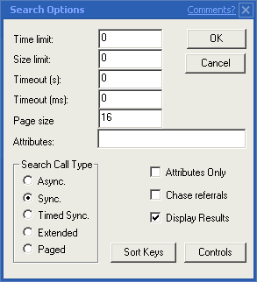

Selecting Async allows you to perform your specific operations and return your call at your leisure. This allows you to perform other task while waiting for your function to return. Otherwise the application could hang while waiting to process your request. To resolve your request select..
- Browse
- Process Pending

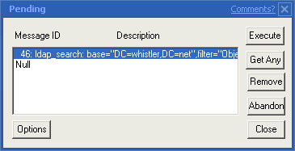

Select the function you want to return and select execute. Note, remember to set the proper time and timeout values. Otherwise your function will timeout before you execute. For more information on Async vs Sync options see

http://www.microsoft.com/WINDOWS2000/library/howitworks/activedirectory/ldap.asp

Sort Keys
Sorting Search Results (controlType 1.2.840.113556.1.4.473)
The sortKeyRequestControl specifies one or more attribute types and matching rules for the results returned by a search request, as well as a flag indicating forward or reverse order. The server should return all results for the search request in the order specified by the sort keys. To select your specific sort keys you can select
- Options -> Sort Keys
Or you can select them during your specific operation
- Search -> Options -> Sort keys

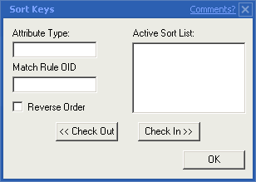

Please see

http://www.microsoft.com/WINDOWS2000/library/howitworks/activedirectory/ldap.asp

For more information.

UNI/BER
These 2 functions are mainly for Adding/Modifying a specific object. UNI lets you add a Unicode string into the Attribute. Attribute such as UserPassword are Unicode. BER allows you to add a Binary Value into an attribute. For example, you could add a JPG file into the attribute for the user object. Todo this, select

- Browse -> Modify
- Enter in the DN you wish to modify
- Enter the Attribute you wish to modify (For Example: ThumbNailPhoto)
- Select Insert File and select a Picture file (*.bmp,*.jpg…etc.)
- Select Enter
- Select Run

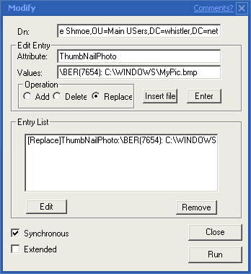

For more information on UNI/BER see

http://www.microsoft.com/WINDOWS2000/library/howitworks/activedirectory/ldap.asp

Interger and Enumeration
Integer and Enumeration
The value specified in a filter must be a decimal Integer. Hexadecimal values must be converted to decimal.
Note that the LDAP matching rule controls can be used to perform bit-wise comparisons.
Matching rules have the following syntax:
attributename:ruleOID:=value
where attributename is the lDAPDisplayName of the attribute, ruleOID is the OID for the matching rule control, and value is the value you want to use for comparison.
Active Directory supports the following matching rules.
Matching rule OID | Description
1.2.840.113556.1.4.803 | LDAP_MATCHING_RULE_BIT_AND The matching rule is true only if all bits from the property match the value. This rule is like the bit-wise AND operator.
1.2.840.113556.1.4.804 | LDAP_MATCHING_RULE_BIT_OR The matching rule is true if any bits from the property match the value. This rule is like the bit-wise OR operator.

Examples of Integer and Enumeration
Filter specifying groupType of Universal group (ADS_GROUP_TYPE_UNIVERSAL_GROUP is 0x00000008).
(groupType=8)
Filter specifying groupType of security-enabled Universal group (ADS_GROUP_TYPE_SECURITY_ENABLED is 0x80000000). So, ADS_GROUP_TYPE_SECURITY_ENABLED | ADS_GROUP_TYPE_UNIVERSAL_GROUP is 0x80000008 and converted to decimal value is 2147483650.
(groupType=2147483650)
Bit-wise comparisons
Filter specifying groupType with the ADS_GROUP_TYPE_SECURITY_ENABLED bit set:
(groupType:1.2.840.113556.1.4.804:=2147483648) )
The following query string searches for Universal distribution groups (that is, Universal groups without ADS_GROUP_TYPE_SECURITY_ENABLED flag):
(&(objectCategory=group)((&(groupType:1.2.840.113556.1.4.804:=8)(!(groupType:1.2.840.113556.1.4.803:=2147483650)))))

Using LDP for Basic information
As you have seen LDP can be used for many functions. Again, in its most basic form LDP simply turns LDAP API’s into a GUI form for easier use. LDP can tell you a lot about the specific LDAP directory that you are connected to. Most commonly would be ROOTDSE information. Simply connect to the server. Standard LDAPv3 directories support ROOTDSE RFC. This data would be returned and you can look at all the basic information that the Directory has. Most commonly would be the Default NC’s and supported controls. Also, a Windows 2000 AD ROOTDSE can also show you the Highest UPN for the specified server.

Since this tool only controls LDAP API’s, it can be used for any other standard RFC compliant LDAP Directory. This includes products such as Site Server, Exchange and Windows 2000 Active Directory. Also, there are a lot of use’s to enumerate ACE’s on objects. Keep in mind that although the Active Directory stores and contains all of this data, the snap-in’s themselves might not so easily expose them. There are many settings that are not exposed through the GUI but need to be manually modified. The same concept applies to the registry.

